**Goals:**

Create a twitter clone to let users search for tweets and view them

**User Stories**

1. As a user, I want to be able to input my search so that I can search for tweets.
2. As a user, I want to be able to see the tweets I searched for so that I can view them.
3. As a user, I want to be able the text, video, photo or gifs so that I can view all the contents of tweet.
4. As a user, I want to see the trending hashtags currently on twitter so that I can later use them to search for tweets.
5. As a user, I want to click on the trending hashtags so that I can see the tweets for that hashtags.
6. As a user, I want to click next Page so that I can see the next page of the tweets.

**Flow Diagram (Swimlane)**

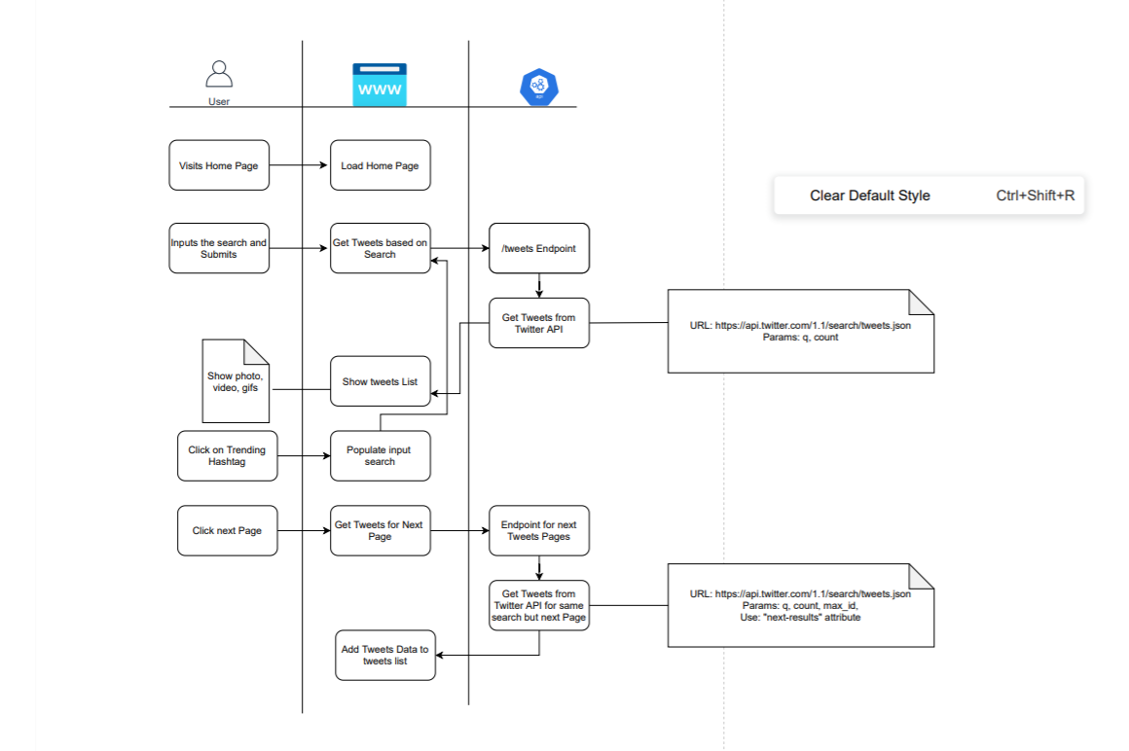

**Business Requirements**

1. Pages
2. Home Page
3. Home Page
4. Allow the user to type in search for tweets based on what they type
5. Show the list of tweets based on search
6. Show text
7. Show images if available
8. Show video if available
9. Shoe gif if available
10. Show how long ago this tweet was created
11. Show the user’s full name who created the tweet
12. Show the profile of the user who created the tweet
13. Show the twitter handle of the user who created the tweet
14. Show 10 tweets only at the start
15. Allow a user to get the next 10 tweets or the next page of tweets
16. Shoe trending hashtags in the list
17. Allow the user to click on the trending hashtag and search for it
18. Show the profile photo of the person using the app

**Technical Requirements**

1. Create a developer Account for Twitter
2. Make sure to only show the next page link when there are results for the next page

* Use the attribute “next_results”

1. Use moment.js for showing the date of the tweet from the current date.
2. Use documentation for getting Search Tweets
3. API Endpoints

* Twitter API
* URL: <https://api.twitter.com/1.1/search/tweets.json>
  + Params:
    - q: query
    - count: for count of tweets
  + Headers:
    - Authorization
      * Bearer <Token>